Human Immunology and Cancer Program
The University of Tennessee Graduate School of Medicine
Alan Solomon, MD
Program Director

American Cancer Society
Clinical Research Professor

Scientific Advisor to the International
Myeloma Foundation

Research Statement

The Human Immunology and Cancer Program (HICP) is a multifaceted basic and clinical scientific endeavor devoted to advancing understanding of the pathogenesis of primary (AL) amyloidosis and developing innovative diagnostic and therapeutic means; the ultimate goal is to eventually diminish or eradicate the calamitous effects of this disease. Our research efforts are directed towards the precise identification and characterization, through immunological, biochemical, and molecular biological techniques, of the protein components that are largely responsible for the devastating manifestations of this disorder. Based on this knowledge, we also are formulating innovative diagnostic and therapeutic approaches for patients with AL amyloidosis. Through use of both in vitro and in vivo experimental models, various chemical and biological substances are being tested to determine their capacity to break down amyloid deposits. Because certain maladies, such as Alzheimer's disease, also are caused by the abnormal deposition of other types of proteins, we anticipate that the results of our work will be beneficial to individuals with these conditions, as well.

Current Clinical Trials
We currently are recruiting patients for the following clinical trials:
Radioimmunoimaging of AL Amyloidosis: The ability to visualize a disease process by CT, PET, or MRI scans provides physicians with an important diagnostic tool, as well as a means to tell if a patient is responding to treatment. In the case of AL (primary) amyloidosis, these techniques are not particularly informative or “amyloid-specific.” Given the need to document the presence and amount of amyloid in major organs, such as the heart, liver, spleen, and kidneys, we are utilizing another strategy; namely, one that is based on our experimental data that have shown that an antibody developed in my laboratory, when labeled with a particular isotope of iodine, can interact with the amyloid, causing it to “light up” when scanned by PET/CT. These findings have led us to initiate an FDA-sponsored trial designed to determine how effective this antibody will be as an amyloid imaging agent. We now are recruiting patients for the study which involves an infusion of the radiolabeled antibody over 10-20 minutes, followed in 48 hours by a 40-minute PET/CT scan which is repeated three days later. To be eligible, individuals must have a confirmed diagnosis of AL amyloidosis and not be on kidney dialysis. There is no charge to participate, except for routine laboratory and other tests, which typically are covered by insurance. For those who live out of town, limited funds are available to cover the cost of transportation, food, and housing.
Human Immune Globulin in Treating Patients with Primary Amyloidosis that is Causing Heart Dysfunction: Patients with AL amyloidosis who have predominant heart involvement unfortunately have a poor prognosis. In this regard, we have found that human immune globulin (an FDA-approved protein product) contains naturally occurring anti-amyloid antibodies and we have shown experimentally that they are capable of eliminating amyloid deposits. Based on these findings, we are conducting a drug company-sponsored trial to determine if human immune globulin indeed can be of benefit to those with heart-related AL amyloidosis. Eligible participants will be given intravenous infusions of this protein (this takes approximately 2 hours) in my clinic once a week for three months and then at two-week intervals during the next 9 months. Although there is no cost for the human immunoglobulin product, patients are responsible for routine clinic and laboratory charges, which typically are covered by insurance.
For more information on these two studies, please contact Dr. Alan Solomon by e-mail (asolomon@utmck.edu).

Amyloidosis: An Overview

Amyloidosis is an abnormal condition whereby protein substances are deposited within the tissues of the body in the form of microscopic fibers called fibrils. It is not a single disease - at least 25 different forms have been recognized. Each is associated with the deposition of a certain protein and, in fact, the designation of a particular kind of amyloid is based on the type of protein involved. Most often, these components are found normally throughout the body or are produced locally by endocrine glands or other organs. Depending on where they are formed or deposited, some of the organs that can be affected by amyloid are kidney, heart, liver, spleen, nerves, pancreas, or brain. Notably, there are multiple diseases associated with this process; certain of these are acquired while others are inherited. Examples of amyloid-related disorders include Alzheimer's disease, the adult form of diabetes, multiple myeloma and related conditions, chronic infections, and the aging process.

Despite the differences in the composition of amyloid, as well as the diseases that result from its deposition, all forms have common features. One, when tissue that contains this material is stained with the dye Congo red and viewed with a microscope equipped with polarizing filters, the amyloid exhibits birefringence, i.e., a striking change in color from deep red to apple green and vice versa.

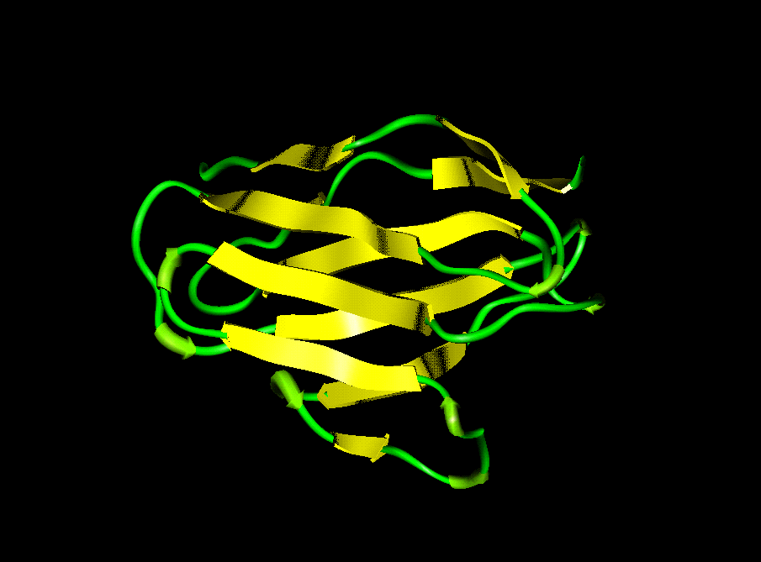
Two, when examined under extremely high magnification with an electron microscope, amyloid appears as rigid, non-branching fibrils. The birefringence and rigidity result from the fact that this material has an unusual structure; namely, these proteins, like silk fibers, assemble as beta-pleated sheets. This feature renders amyloid exceptionally insoluble. Further, it is not viewed by the body as foreign or injurious and, thus, is seemingly protected from "attack" by natural defense mechanisms. Only rarely do the deposits disappear. The invasion of healthy tissue by amyloid interferes with normal body function; over time, this relentless process can lead to organ failure and death.
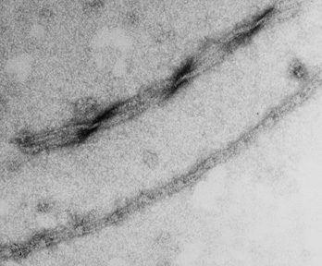

Over the past several decades, extensive research efforts by our laboratory and others throughout the world have provided new information on why certain proteins are deposited as amyloid and how this process occurs. These exciting leads, in addition to other recent developments, have resulted in new methods of diagnosis and strategies for treatment and prevention that ultimately will benefit patients with all types of amyloid.

Primary Systemic Amyloidosis (AL Amyloidosis)

At the Human Immunology & Cancer Program, we have focused our clinical and research efforts on one particular form of amyloidosis - primary systemic amyloidosis - now referred to as AL amyloidosis. The proteins associated with this type of amyloid are composed of antibody-related molecules (immunoglobulins) that are involved in the body's defense against infection. They are made by plasma cells in the bone marrow or in other sites such as the skin, eyes, bladder and vocal cores and are secreted into the blood stream. For unknown reasons, a single population or clone of plasma cells grows excessively (such as occurs in multiple myeloma and other conditions). This leads to an increased production and secretion of these proteins, some of which can eventually form amyloid. Because they result from the proliferation of a single (i.e., monoclonal) plasma cell, the antibodies produced are termed monoclonal immunoglobulins or M-components. One particular type of M-component - Bence Jones protein - was named after its discoverer, Dr. Henry Bence Jones, over 150 years ago. This protein represents a portion of the antibody molecule called the light chain; thus, when this material deposits as amyloid, the resulting condition is designated light chain or AL amyloidosis.

Features of Primary Amyloidosis:

The primary (AL) form of amyloidosis is relatively uncommon, with an incidence of approximately 1 per 100,000 population; it is estimated that about 2,000-3000 new cases are diagnosed each year. The disorder typically is manifested during the fifth or sixth decade of life and is apparently non-inheritable. Because it is fairly rare, it is often overlooked as a cause of organ dysfunction until late in the course of the disease. Tissues that appear to be targeted for AL fibril deposition include kidney, heart, liver, spleen, intestine, tongue, and nerve. Each patient has a particular pattern of organ involvement. In some individuals, the kidney is the predominate organ affected; in others, kidney function is normal and the heart or some other tissue is damaged. Most often, the disease is progressive and ultimately proves fatal within one or two years of diagnosis; however, treatment often can slow the course of illness.

Diagnosis:

Regardless of the organ predominately infiltrated by AL amyloid deposits, this material is typically present in blood vessels throughout the body and can be found readily in Congo red-stained tissue biopsies of kidney or other organs. Often, a simple and relatively painless diagnostic procedure, such as withdrawing a small sample of fat by needle and syringe from under the skin of the abdomen, can provide sufficient material for Congo red staining and analyses. Further, abnormal plasma cells and M-proteins in blood or urine can be readily detected in the laboratory. From the results of these studies, and most importantly from the chemical characterization of the type of protein contained in amyloid-laden tissue, the diagnosis of the AL form of amyloidosis can be established.

Other standard medical procedures are used to identify organs suspected of being involved by the amyloid process. These include examination of the heart by echocardiography or liver and spleen by CT or MRI scans, etc. The use of certain radioactive agents may allow the amyloid deposits to be seen. However, the unequivocal diagnosis of AL amyloidosis cannot be made on the basis of these tests alone. Rather, biopsy of potentially affected tissues is required.

Treatment:

The treatment of patients with primary amyloidosis is presently limited. The main approach has been to control symptoms of the disease that result, for example, from kidney or heart damage. Much attention has been given to reducing the number of plasma cells and, thus, the amount of M-protein that is eventually deposited as amyloid. This can be accomplished with chemotherapeutic drugs, such as melphalan and prednisone or high-dose dexamethasone, that also are used in multiple myeloma. In some cases, bone marrow or stem cell transplants have made it possible to achieve this effect since higher doses of chemotherapy can be administered. The resultant reduction in protein levels has been associated with prolongation of life and in some cases, the amyloid deposits seemingly are resolved over time. However, more often they progress and organ deterioration worsens. In the case of patients whose kidneys have failed due to amyloid deposits and who are on dialysis, a renal transplant offers hope. Cardiac transplantation may be beneficial in rare instances. Overall, however, the prognosis of AL amyloidosis still remains poor.

Amyloid Research

AL amyloidosis (as well as other forms of the disease) is the subject of intense scientific investigation. Here at the Human Immunology and Cancer Program, we have extensive laboratory and support facilities staffed by dedicated professional and technical personnel who are engaged in research of this disorder. Also participating are international visiting scientists who are among the world's experts in this field. Medical care, including diagnostic procedures, treatment, and consultative services, are provided in a clinic devoted to people with AL amyloidosis. Thus, the patient is a participant and an integral part of the research efforts.

We have formulated medically based strategies designed to answer questions that are deemed critical to solving this devastating problem:

- How can the diagnosis of the disease be improved?

- What causes certain types of light chains (Bence Jones proteins) to form amyloid fibrils?

- Why are particular organs or tissues apparently "targeted" for fibril deposition and what accounts for the differences observed between patients in the organs predominately affected?

- How can fibrils be eliminated once laid down or even prevented from forming or depositing?

- Finally, is this disease dependent upon the injurious nature of the protein itself, or do people with this disorder have some sort of defect that causes these proteins to form amyloid, or do they lack antibodies or other substances that can help remove this material once deposited?

The fact that amyloidosis is not a single disease, but rather is a group of disorders that results from the pathologic deposition of at least 25 different proteins, necessitates that physicians have knowledge of the exact type of amyloid occurring in their patients since the prognoses of the various amyloidoses differ and each type requires individualized treatment. Because all forms of amyloid are similar in appearance when viewed through a microscope, they can not be distinguished from one another on this basis, and thus, alternative methods have been developed and utilized to identify indirectly the nature of this substance. However, to establish unequivocally the particular kind of amyloid present, it is necessary that this material be selectively removed from tissue and analyzed in the laboratory for determination of its exact chemical composition. This can be a formidable task and, until recently, required that a relatively large sample be used for study. Fortunately, we now have developed a "micro-technique" that makes it possible to gain such information from minute tissue specimens obtained by fine needle biopsy or fat aspiration.

Because patient as well as protein factors can be involved in the generation of amyloidosis, our research also is directed towards elucidation of antibody-related genes and the development of experimental models of this disease. Further, after proteins that make up the amyloid are isolated from tissue specimens and analyzed in the laboratory, we can compare them to other samples to determine if amyloid-forming proteins differ from those that are not involved in this process. Such information can be used as the basis for generation of drugs and other compounds that will be helpful in treatment. Additionally, work is underway to determine if tissue specific factors are present in particular organs that "attract" or bind light chains and result in fibril formation. If such a structure is identified, agents could be designed that would prevent the binding of light chain proteins to tissues and thus amyloid production would be prevented. We also are studying ways to elicit from the body a natural defense response that would eliminate these abnormal deposits before irreparable organ damage occurs and have developed certain reagents called monoclonal antibodies that are attracted specifically to the unique structure of amyloid proteins. When these antibodies are given to animals that have amyloid deposits, this material disappears rapidly. Our highest priority is to determine if such reagents would be beneficial in patients with AL amyloidosis. In this regard, the National Cancer Institute, through their "Rapid Access to Intervention Development (RAID)" program has prepared one of our "anti-amyloid" monoclonal antibodies in a form that can be administered to humans and plans to produce a sufficient amount of this clinical-grade reagent for a Phase I/II trial in patients with this disease. The use of this form of "passive" immunotherapy to remove amyloid deposits would be a major advance in the treatment of AL, as well as other amyloid associated diseases. Additionally, we currently are investigating the capability of one such amyloid-reactive monoclonal antibody, when labeled with a radioactive isotope, to serve as a PET imaging agent.

These areas of ongoing study that combine patient care and laboratory research ultimately offer hope to patients with AL amyloidosis. Because each case is unique and offers important information, continued research and careful study of individual patients will help achieve the goal of curing or preventing this devastating illness.

Contact Information

If you have questions or comments for Dr. Solomon regarding amyloidosis or Multiple Myeloma, please reply by e-mail (asolomon@utmck.edu) or fax (865-305-6865). To receive a response, you must include your complete name, mailing address, and a daytime phone number. Because it is not feasible to diagnose or give medical advice over the Internet, contact with your physician is required. It also may be necessary to have serum, urine, and tissue biopsy specimens sent for special studies. To cover the cost of these services, a charge will be rendered for consultation and laboratory analyses.

